Question1a.
The crabs dataset in the MASS package contains measurements of various physical characteristics of crabs. The dataset includes the following variables:
- sp: species of crab (categorical variable with two levels: "B" for blue crab and "O" for orange crab).

1b
install.packages("MASS")
library(MASS)
data(crabs)
str(crabs)
data.frame': 200 obs. of 8 variables:
$ sp : Factor w/ 2 levels "B","O": 1 1 1 1 1 1 1 1 1 1 ...
$ sex : Factor w/ 2 levels "F","M": 2 2 2 2 2 2 2 2 2 2 ...
$ index: int 1 2 3 4 5 6 7 8 9 10 ...
$ FL : num 8.1 8.8 9.2 9.6 9.8 10.8 11.1 11.6 11.8 11.8 ...
$ RW : num 6.7 7.7 7.8 7.9 8 9 9.9 9.1 9.6 10.5 ...
$ CL : num 16.1 18.1 19 20.1 20.3 23 23.8 24.5 24.2 25.2 ...
$ CW : num 19 20.8 22.4 23.1 23 26.5 27.1 28.4 27.8 29.3 ...
$ BD : num 7 7.4 7.7 8.2 8.2 9.8 9.8 10.4 9.7 10.3 ...

1c
species_freq <- table(crabs$sp)
sex_freq <- table(crabs$sex)
print(species_freq)
print(sex_freq)
B O
100 100
F M
100 100

1d
barplot(species_freq, main = "Frequency of Crab Species", xlab = "Species", ylab = "Frequency", col = "red")
barplot(sex_freq, main= "Frequency of
Crab Sex", xlab = "Sex", ylab = "Frequency", col = "green")

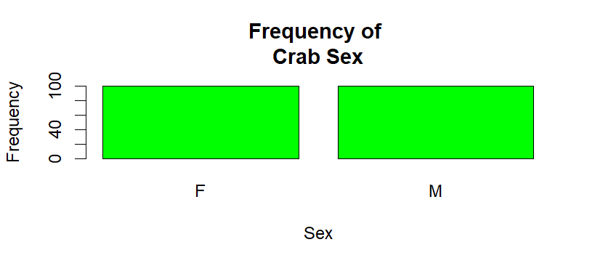
1e.
To determine if the dataset is balanced across the four groups (species and
sex), we can look at the frequency tables for both variables. If the counts for each group are similar, we can say that the dataset is balanced.

Question 2a.
boxplot(BD ~ sp + sex, data = crabs, main = "Boxplot of Body Depth by Species and Sex", xlab = "
Species and
Sex", ylab = "Body Depth (BD)", col = c("blue", "pink"))

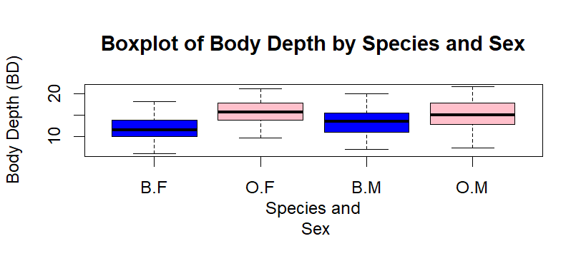
2b.
Yes, there are outliers in the boxplot. The points that fall outside the whiskers of the boxplot represent outliers in the body depth (BD) measurements for both species and sex groups.
To compare the central tendency and variability between groups, we can look at the median (central tendency) and the interquartile range (variability) for each group in the boxplot. The median is represented by the line inside the box, while the interquartile range is represented by the height of the box. By comparing the medians and the heights of the boxes for each group.

Question 3a.
par(mfrow = c(1, 2))
hist(crabs$CL[crabs$sp == "B"], main = "Histogram of Carapace Length (CL) for Blue Crabs", xlab = "Carapace Length (CL)", col = "yellow")
hist(crabs$CL[crabs$sp = "O"], main = "Histogram of Carapace Length (CL) for Orange Crabs", xlab = "Carapace Length (CL)", col = "brown")
par(mfrow = c(1, 1))

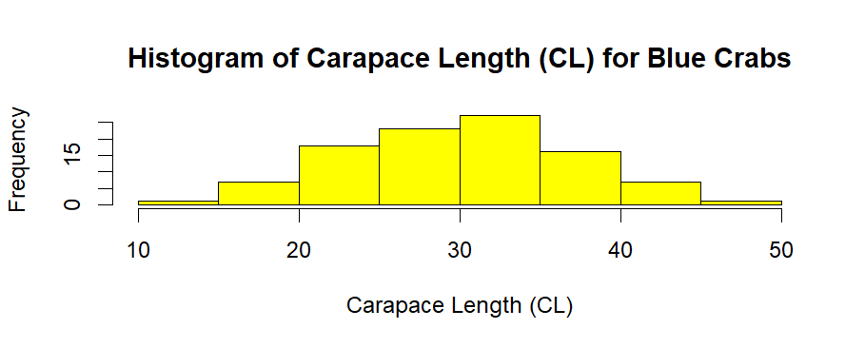

3b.
For the blue crabs (B), the histogram may show a distribution that is approximately normal, with a single peak (unimodal) and relatively symmetric around the mean. The skewness may be close to zero, indicating that the distribution is not skewed.
- For the orange crabs (O), the histogram may show a distribution that is skewed to the right (positively skewed), with a longer tail on the right side. This indicates that there are more crabs with larger carapace lengths. The distribution may also be unimodal, but the skewness would be greater than zero, indicating a positive skew.

Question 4a.
library(dplyr)
mean_measurements <- crabs %>%
group_by(sp, sex) %>%
summarise(mean_FL = mean(FL), mean_RW = mean(RW), mean_CL = mean(CL), mean_CW = mean(CW), mean_BD = mean(BD))

print(mean_measurements)

sp sex mean_FL mean_RW mean_CL mean_CW mean_BD
<fct> <fct> <dbl> <dbl> <dbl> <dbl> <dbl>
1 B F 13.3 12.1 28.1 32.6 11.8
2 B M 14.8 11.7 32.0 36.8 13.4
3 O F 17.6 14.8 34.6 39.0 15.6
4 O M 16.6 12.3 33.7 37.2 15.3

4b.
library(ggplot2)
mean_measurements_long <- mean_measurements %>%
pivot_longer(cols = starts_with("mean_"), names_to = "Measurement", values_to = "Mean")

Question 5a
pairs(crabs[, c("FL", "RW", "CL", "CW", "BD")], main = "Scatterplot Matrix of Morphological Measurements", pch = 19, col = "green")

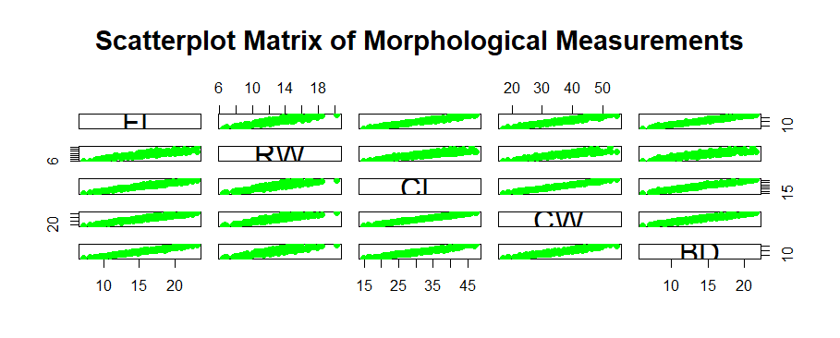
5b.
To describe the strength and nature of the relationships among the variables (FL, RW, CL, CW, BD), we can look at the scatterplot matrix we created.
- If we see a strong positive correlation between two variables, it means that as one variable increases, the other variable also tends to increase. For example, if we see a strong positive correlation between carapace length (CL) and carapace width (CW), it suggests that larger crabs tend to have wider carapaces.
- If we see a strong negative correlation between two variables, it means that as one variable increases, the other variable tends to decrease. For example, if we see a strong negative correlation between body depth (BD) and carapace length (CL), it suggests that crabs with longer carapaces tend to have shallower body depths.
- If we see a weak or no correlation between two variables, it means that there is little to no relationship between them. For example, if we see a weak correlation between frontal lobe length (FL) and rear width (RW), it suggests that these two measurements do not have a strong relationship with each other.

Question 6.
The crabs dataset from the MASS package contains measurements of various physical characteristics of crabs, including species (B for blue crab and O for orange crab) and sex (M for male and F for female). The dataset includes measurements such as frontal lobe length (FL), rear width (RW), carapace length (CL), carapace width (CW), and body depth (BD).

